|  |  |  |  |  |  |  |
| --- | --- | --- | --- | --- | --- | --- |
| **Stage** | **Sessions** | **Bounce Rate** | **Page views** | **Unique page views** | **Average Session Duration** | **% New Sessions** |
|  |  |  |  |  |  |  |
|  |  |  |  |  |  |  |
| May 01- 07th | 37 | 78.38 | 66 | 33 | 00:01:28 | 72.97% |
| May 08-14th | 34 | 32.35% | 112 | 28 | 00:04:39 | 67.65% |
| May 15- 21st | 125 | 34.40% | 441 | 94 | 00:03:50 | 69.60% |
| May 22- 28th | 119 | 59.66% | 262 | 94 | 00:03:53 | 58.82% |
| May 1st to May 31st | 550 | 49.64% | 1,659 | 347 | 00:03:21 | 60.40% |

**MONTHLY ANALYSIS REPORT:**

**ACQUISITION OVERVIEW:**

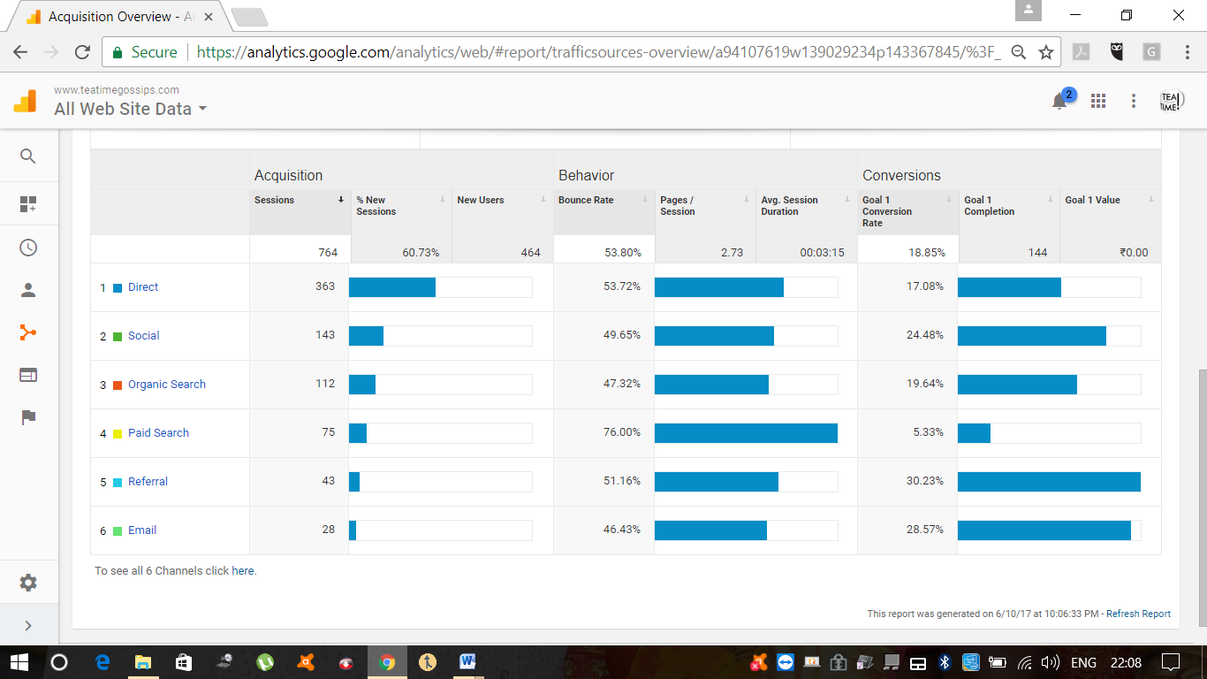

|  |  |
| --- | --- |
| **FINAL REPORT:** |  |

Note: In Acquisition Analytics there is no page views column, so I am leaving that column.

|  |  |  |  |  |  |  |  |
| --- | --- | --- | --- | --- | --- | --- | --- |
|  |  |  |  |  |  |  | Goal |
| Channel | # Sessions | Bounce |  | Unique | Average | % new | Conversions |
|  |  | Rate | Page views | Page views | Session | sessions |  |
|  |  |  |  |  | Duration |  |  |
| Direct | 364 | 53.85% |  | 227 | 00:03:33 | 62.36% | 62 |
| Organic | 112 | 47.32% |  | 78 | 00:02:04 | 69.64% | 22 |
| Email | 28 | 46.43% |  | 3 | 00:04:28 | 10.71% | 8 |
| Ad Words | 75 | 76.00% |  | 61 | 00:01:38 | 81.33% | 4 |
| Facebook | 97 | 44.33% |  | 57 | 00:05:26 | 58.76% | 25 |
| YouTube | 1 | 100% |  | 1 | 00:00:00 | 100% | 1 |
|  | | |  |  |  |  |  |
|  | | |  |  |  |  |  |